Generative Adversarial network(GAN)-
GAN combination of two model - Generator and Discriminator.
Discriminator- Model learns the conditional probability of the target variable given input variable like Linear regression , Logistic regression. we use discriminator to tell if given data point is an original one or generate by our generator.
Generator- The model learns the joint probability distribution of the input and output variable on bayes theorem example naive bayes model. we produce fake data points using generator.
Both Models compete with each other get better and better in there job.
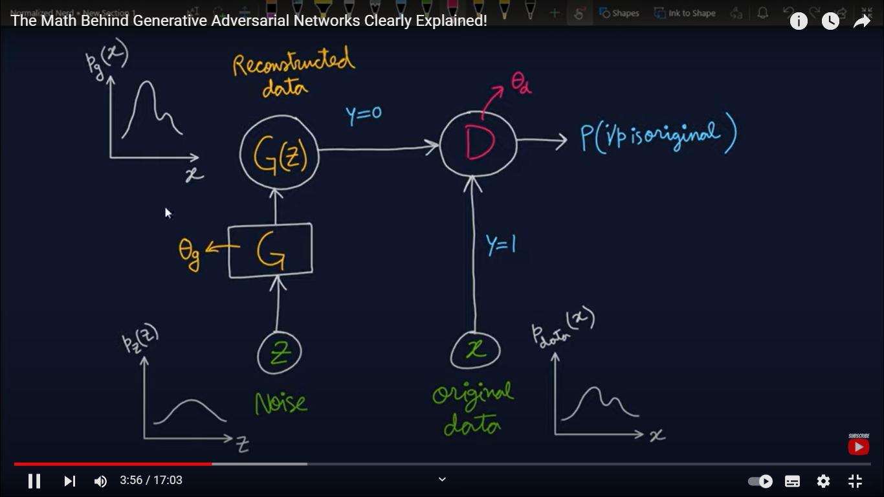

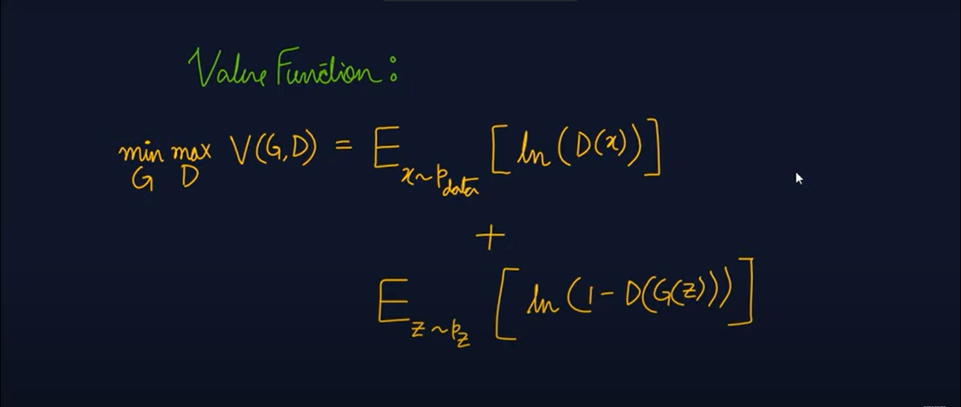
Value function is similar like binary cross entropy loss formula .
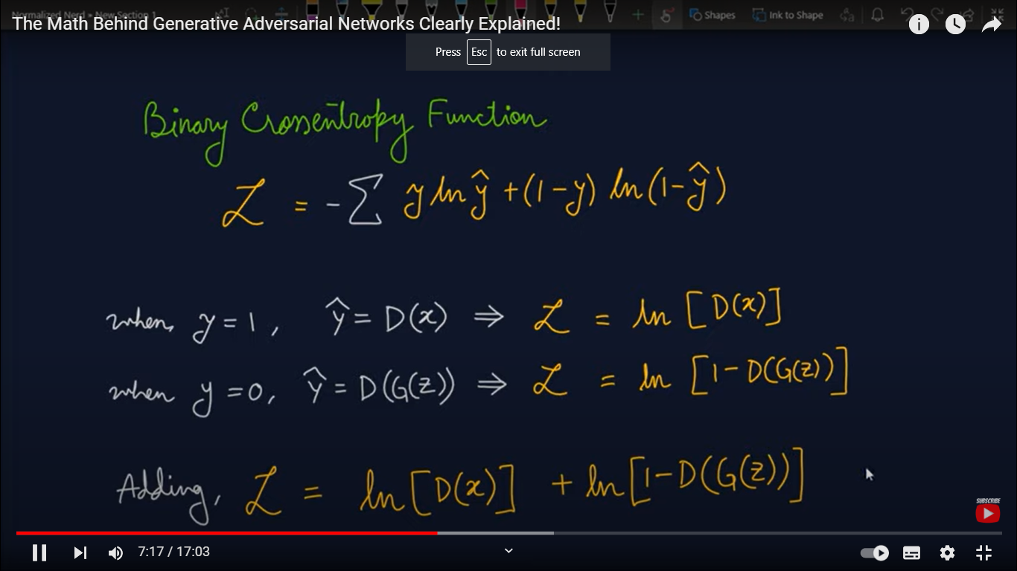
Training-
Fix the learning of G.
Take m data samples and m fake data samples.
Update weights by gradient ascent(as discriminator try to maximise the value function).
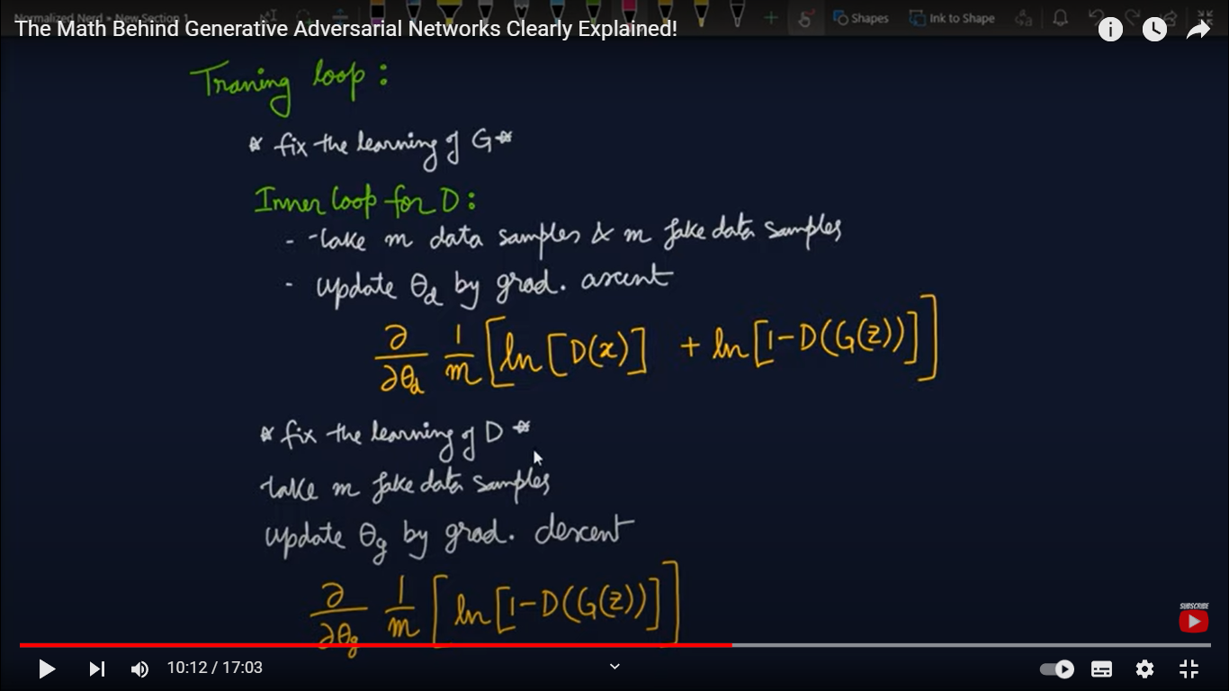
Now,
Fix learning of D to train Generator.
Take m data fake samples.
Update weights by gradient descent.

For fixed G,
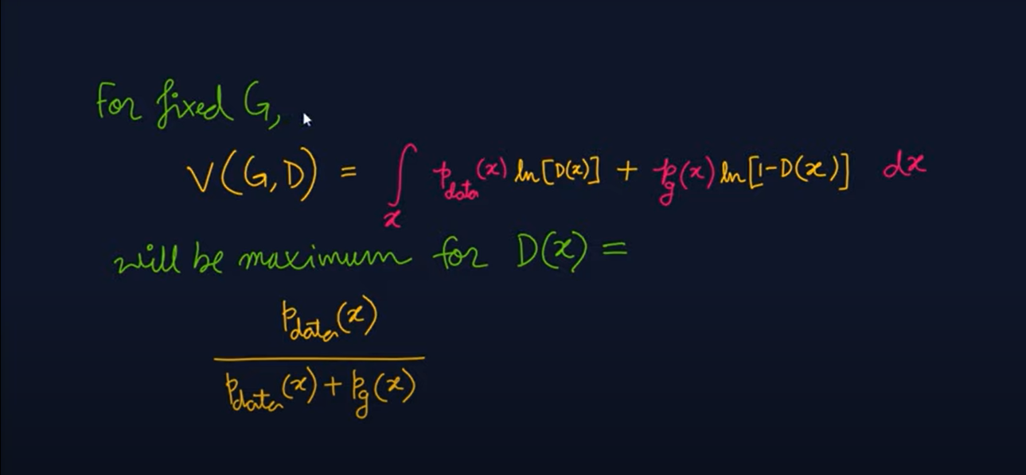
Will be maximum for D(x)= p(x)data/p(x)data + p(x)noise

For fixed D,
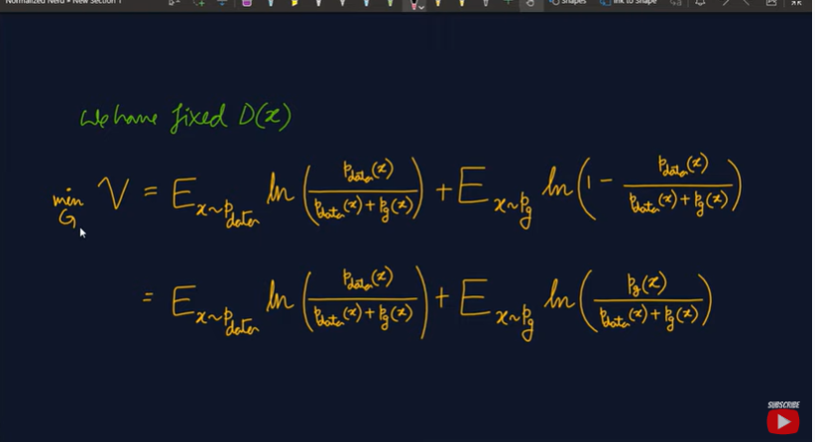

Vmin=-2ln2

